Explorer’s Way
If you love adventure, you can’t beat a trip along Explorer’s Way, one of the great Australian road trips. Explorer’s Way passes some of Australia’s favourite natural icons, including Uluru and Kata Tjuta, Watarrka/Kings Canyon, the MacDonnell Ranges, Karlu Karlu/Devils Marbles, Nitmiluk National Park and the waterfalls of Litchfield National Park.
The Explorer’s Way journey is recommended to be done over a minimum 14 days on a sealed highway following the route of the 1862 explorer John McDouall Stuart.
DO DARWIN
Ride the swell at the Wave Pool, eyeball a croc in the ‘Cage of Death’, or enjoy one of Darwin’s famous Asian inspired markets in Australia’s tropical capital city. While in Darwin why not explore one of the Top End’s much loved natural icons – Litchfield National Park.
DO KATHERINE
Where the outback meets the tropics - discover a region full of gorges and misty waterfalls, thermal springs and ancient cultures. Located in Nitmiluk National Park, the mighty Katherine Gorge is also a must do, with dozens of spots to enjoy a dip in the water.
DO MATARANKA
Mataranka, a small community located only 100km south of Katherine, is more than just a stopover on the Explorer’s Way. Why not stop, relax and take a dip in the Mataranka or Bitter Springs thermal pools, bubbling up at a fairly constant temperature of 34 degrees Celsius.
DO DALY WATERS
In between Katherine and Tennant Creek is a unique pub that could only belong in the NT. Daly Waters attracts visitors from all over Australia and beyond, wanting to relax after a long drive and enjoy Daly’s famous outback tucker, cold beer and live music. Daly is a must do on your NT adventures.
DO TENNANT CREEK
Learn about the local indigenous culture and see artworks from the region at the Nyinkka Nyunyu Art and Culture Centre. Discover the early history of the pioneers, the introduction of telegraph communications, mining, police and hospital infrastructure in the region at Tennant Creek’s fascinating array of museums.
DO ALICE SPRINGS
Visit the spiritual heart of Australia, with rivers and ranges millions of years old and an ancient Aboriginal culture rich in art and stories. Discover the stunning landscapes, remote communities, and a unique pioneering history. Alice Springs is your basecamp to adventure and it’s easier to get here than you think!
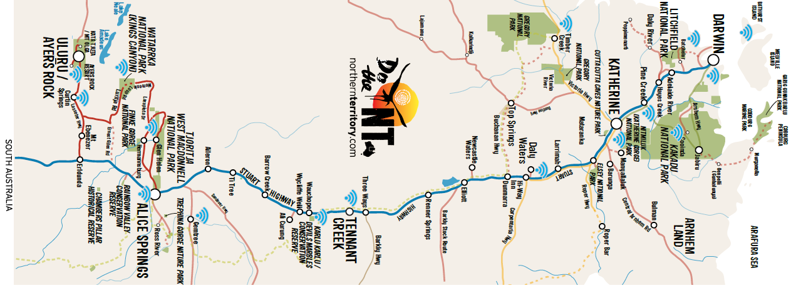
Do Explorer’s Way – 14 day suggested itinerary
DAY 1-4 - 846km
ADELAIDE TO COOBER PEDY
Along the journey from South Australia to Coober Pedy, why not stop into Port Augusta, a great base to explore the Southern and Central Flinders Ranges.
DAY 5 - 734km
COOBER PEDY TO ULURU
Once you have arrived at Uluru-Kata Tjuta National Park - discover the spiritual heart of the Australian Outback. Home to the great icons of Uluru and Kata Tjuta, this desert region is blessed with natural wonders, world class dining experiences and rugged beauty.
DAY 6 - 300km
ULURU TO KINGS CANYON
Leave the Uluru-Kata Tjuta National Park and drive 300km back along the Lasseter and Luritja highways to Watarrka/Kings Canyon. This majestic destination features 100m high sandstone walls, walking trails and views that will leave you speechless.
DAY 7 - 474km
KINGS CANYON TO ALICE SPRINGS
For an unforgettable view of the canyon, rise before dawn and follow the 6km trail around its rim. Once you get back on the road, head to the NT’s second largest city, Alice Springs. If travelling by four-wheel drive, head via Mereenie Loop, Travel again along the sealed Luritja and Lasseter highways, before turning north onto the Stuart Highway.
DAY 8 - 130km
WEST MACS, ALICE & GLEN HELEN
The West MacDonnell Ranges are an easy day trip from Alice Springs along a sealed road. There are many stops along the way to enjoy. Walk along the trail at Simpsons Gap or stand between the sheer walls of Standley Chasm. To cool off why not enjoy a swim at Ellery Creek Big Hole, Ormiston Gorge, Glen Helen Gorge or Redbank Gorge.
DAY 9 - 510km
ALICE SPRINGS TO TENNANT CREEK
On your journey from Alice to Tennant, why not stop in at the Devils Marbles, a sacred site known as Karlu Karlu to the Warumungu people. These massive ancient granite boulders are strewn across a wide shallow valley, and continue to crack and change.
DAY 10 - 400km
TENNANT CREEK TO DALY WATERS
The Daly Waters Historic Pub is a popular place to overnight that offers backpacker, hotel or motel rooms. The pub and grounds are crammed with memorabilia that reveal the pub’s colourful history and who has passed through its doors. This place is worth a longer stay, so set up camp for the night.
DAY 11- 167KM
DALY WATERS TO MATARANKA
Take a break from all the driving and enjoy a rejuvenating swim in the Mataranka Thermal Pool. Fed by spring water in the Daly and Georgina basins, it is surrounded by a palm forest and its waters are a constant 34 degrees Celsius.
DAY 12 - 106km
MATARANKA TO KATHERINE
Katherine is the NT’s fourth largest town, and a perfect base to check out the nearby gorge country. Why not explore the vast Nitmiluk National Park’s thirteen gorges via a helicopter joy flight, canoe or join a guided cruise. About 40km north of Katherine is Leliyn Falls (Edith Falls) – a great place for a cooling swim.
DAY 13 - 265km
KATHERINE TO LITCHFIELD
Litchfield National Park’s close proximity to Darwin and unspoiled beauty makes this park a popular spot with day-trippers who come from the city for a dip in the Florence Falls plunge pool, Buley Rockhole, and Wangi Falls. Walking tracks, camping facilities and 2WD and 4WD accessible tracks means there is an adventure to suit everyone.
DAY 14 - 130km
LITCHFIELD TO DARWIN
Follow the Explorer’s Way for your first glimpse of the Timor Sea and into Darwin, Australia’s northernmost capital city. You will find yourself in a contemporary multicultural metropolis of open-air markets, festivals, Asian-influenced cuisine, and an outdoor lifestyle.

TOP 5 THINGS TO DO
- Cool off in the waterholes of the West MacDonnell Ranges which stretch west of Alice Springs
- Take a break from the driving and enjoy a rejuvenating swim in the Mataranka Thermal Pool, fed by spring water at a constant 34 degrees
- Enjoy some outback tucker at the celebrated Daly Waters Pub
- Join a Nitmiluk dinner cruise and marvel at the mighty Katherine Gorge and ancient art
- Eyeball a croc in the “Cage of Death” at Darwin’s Crocosaurus Cove

